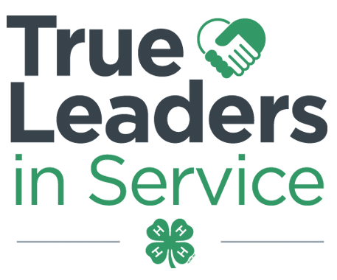
Contra Costa County 4-H Resource Center http://4hcontracosta.ucanr.edu
75 Santa Barbara Rd. Floor 2, Pleasant Hill, CA 94523
[Office] 925-646-6543, [Fax] 925-646-6708
Lisa Arbuckle [Email] lafrederickarbuckle@ucdavis.edu
Brenda Vales [Email] bcvales@ucdavis.edu

August 28, 2017

PROGRAM SUPPORT
Thank you for all who attended the Community Club Leader retreat.

2017/2018 Beginning 4-H for Volunteers
- Required for new adult volunteers.
- Beginning 4-H for Volunteers (Orientation); 10:00 AM – 2:00 PM (bring bag lunch)
  - Sept. 10 (Hayward)
  - Oct. 14 (Hayward)
  - Oct. 15 (Pleasant Hill)
  - Nov. 4 (Pleasant Hill)
  - Dec. 9 (Pleasant Hill)
  - Dec. 10 (Hayward)

New Volunteer information and to Register at: http://ucanr.edu/cc4hvolunteer

FACILITY USE
Requests are processed Monday & Wednesdays. Questions may be directed to Lisa via email.

ALL events/gatherings/meetings (organized by 4-H youth/adults) are to be logged using the link below.
- http://ucanr.edu/log4hmeeting

FISCAL
Year-end reports are due September 15th.

Required Forms Checklist 2016-2017
- Annual Inventory Report Form 6.2
- Annual Financial Report Form 6.3
- Year-End Club Peer Review Report Form 8.5
- Year-End Club Peer Review Checklist Form 8.6
- Outreach Methods Documentation Report
- Club Program Planning Guide
Required Forms Checklist 2017-2018
- Proposed Club Program Planning Guide
- Proposed Club Budget Form 8.4
- Proposed Club Program Planning Guide

ENROLLMENT
ALL clubs should be confirming members as they are enrolled. Club Leaders, VEC’s and Treasurers please work together to get your youth members confirmed.

Club Leaders and VEC please email any project revisions to Brenda to ensure they are correct at 4HOnline. Project leader must be included with all requests

2017-2018 Contra Costa County 4-H Fees:
Youth - $75.00 ($46 State, $25 County, $4 Council)
Adult - $16.00 ($16 State, $0 County)

Annual Request to Access Unit 4-H Program fee – see link: 4h.ucanr.edu/files/4750.docx

ENROLLMENT DEADLINE: December 1, 2017
This applies to all returning 4-H members that were enrolled in the 2015-2016 program year. Must be confirmed by club VEC within 4HOnline by deadline.

OUTREACH
- Record your Outreach activities as they happen at http://ucanr.edu/outreach
- Collect outreach stories, published news articles, photos or anything positive about
4-H youth and/or the 4-H program.
- A confirmation of the submission will be sent to you for your records. The paper form is also acceptable.

National 4-H Week: October 1 – 7th, 2017 and theme for 2017 is #TrueLeaders
UPCOMING TRAINING
Wed. 8/30 – VEC Training – Zoom Call
Sat. 9/9 - Treasurer Training - Alameda
Sat. 9/16 - Treasurer Training - Contra Costa
Thu. 10/5 – Cultivating an Environment for Growing True Leaders

