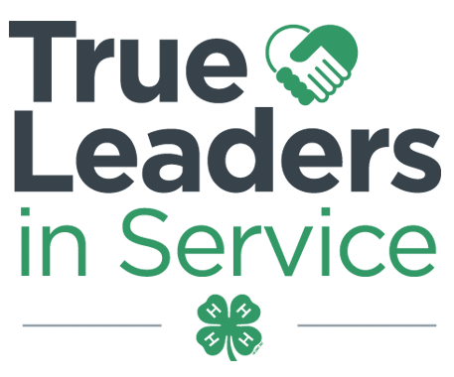
Contra Costa County 4-H Resource Center http://4hcontracosta.ucanr.edu
75 Santa Barbara Rd. Floor 2, Pleasant Hill, CA 94523
[Office] 925-646-6543, [Fax] 925-646-6708
Lisa Arbuckle [Email] lafrederickarbuckle@ucdavis.edu
Brenda Vales [Cell] 707-205-6303, [Email] bcvales@ucdavis.edu

November 6, 2017

PROGRAM SUPPORT
California Handbook for New Families available on the State and County website under Resources

BYLAWS All 4-H Leaders’ Councils and 4-H Clubs are required to use the State 4-H templates for Bylaws & Constitution. They were to be submitted by November 1, 2017. Please let me know if an extension is needed.

Call for Science Matters Project Leaders
General Description
Alameda and Contra Costa 4-H Programs have been selected to participate in a new nationwide project called Science Matters. Its long-term goal is to drive youth to a pathway that will deepen their understanding of how science connects to their food, animals and health; spark their interest in agri-science careers; and empower them with the skills and support to show their communities just how much science matters.

The 4-H Science Matters Adult Volunteer:
- Advises and assists 4-H members in planning events and activities.
- Identifies resources available to help members plan agri-science activities.

2017/2018 Beginning 4-H for Volunteers
- Required for new adult volunteers.
- Beginning 4-H for Volunteers (Orientation); 10:00 AM – 2:00 PM (bring bag lunch)
- Livescan Available
  - December 9 (Contra Costa)
  - December 10 (Hayward)
- Register at http://ucanr.edu/beginning4hforvolunteers

FACILITY USE
Requests are processed Monday & Wednesdays. Questions may be directed to Lisa via email.

ALL events/gatherings/meetings (organized by 4-H youth/adults) are to be logged using the link below.
- http://ucanr.edu/4-HFacilityUseSurvey

HELPFUL TIP
Did you know, that if you are just adding or changing a date to a project already entered on the survey, you do not need to create another survey, as long the location remains the same. Just email the new dates to Lisa.

FISCAL

YEAR END REPORTS - Past due

There are clubs that have not submitted all reports.

State and County fees are due to the County Office by Friday, January 19, 2018

OUTREACH

Record your Outreach activities as they happen at http://ucanr.edu/outreach or complete the Outreach Methods Documentation Form.

ENROLLMENT
ENROLLMENT DEADLINE: December 1, 2017
This applies to all returning 4-H members and adult volunteers that were enrolled in the 2016-2017 program year. Must be confirmed by club VEC within 4HOnline by deadline.

Do not confirm any youth members that have not paid fees or turned in a waiver of fees.

Do not confirm any adults until you have been notified by the county office that they have completed the required process.

I am still receiving project list updates. Project leader must be included when asking to add a project.

2017-2018 Contra Costa County 4-H Fees:
Youth - $75.00 ($46 State, $25 County, $4 Council)
Adult - $16.00 ($16 State, $0 County)

Remember There are online course requirements for all adult volunteers. New and returning Volunteer information is at: http://4hcontracosta.ucanr.edu/Join-4-H/County_Volunteer/

UPCOMING TRAININGS

12/7/17 – Helping 4-H’ers Grow in Life & Work - County Office 3:30PM-5:30PM

STATE NEWS
Evaluators needed for State Record Book Competition. Evaluations will all be completed online. Apply at http://ucanr.edu/survey/survey.cfm?surveynumber=15660

