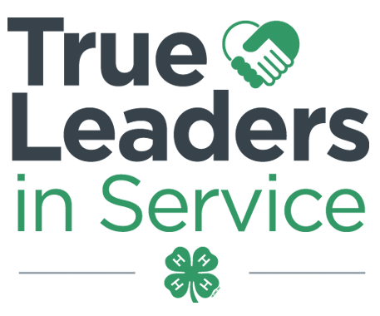
Contra Costa County 4-H Resource Center http://4hcontracosta.ucanr.edu
75 Santa Barbara Rd. Floor 2, Pleasant Hill, CA 94523
[Office] 925-646-6543, [Fax] 925-646-6708
Lisa Arbuckle [Email] lafrederickarbuckle@ucdavis.edu
Brenda Vales [Cell] 707-205-6303, [Email] bcvales@ucdavis.edu

January 2, 2018

PROGRAM SUPPORT
Call for Science Matters Teens
Alameda and Contra Costa 4-H Programs have been selected to participate in a new nationwide project called Science Matters. Its long-term goal is to drive youth to a pathway that will deepen their understanding of how science connects to their food, animals and health; spark their interest in agri-science careers; and empower them with the skills and support to show their communities just how much science matters.

We are in need of 2-3 teens and available to attend the Agri-Science Youth Summit January 12-15, 2018.

Recruitment for Treasurer Training Subcommittee
The 4-H Policy Advisory Committee is recruiting for members to serve on a special subcommittee to develop
4-H Treasurer’s Trainings. Those serving on this subcommittee would not need to participate in any other tasks associated with the 4-H Policy Advisory Committee and would solely focus on the development of this resource. If you know of any youth or adult volunteers who have experience as or working with Treasurers, please email the office.

FACILITY USE
Requests are processed Monday & Wednesdays. Questions may be directed to Lisa via email.

ALL events/gatherings/meetings (organized by 4-H youth/adults) are to be logged using the link below.
- http://ucanr.edu/4-HFacilityUseSurvey

FISCAL

State and County fees are due to the County Office by Friday, January 19, 2018

OUTREACH

Record your Outreach activities as they happen at http://ucanr.edu/outreach or complete the Outreach Methods Documentation Form.

ENROLLMENT
ENROLLMENT DEADLINE: December 1, 2017
This applies to all returning 4-H members and adult volunteers that were enrolled in the 2016-2017 program year. Must be confirmed by club VEC within 4HOnline by deadline.

Do not confirm any youth members that have not paid fees or turned in a waiver of fees.

Do not confirm any adults until you have been notified by the county office that they have completed the required process.

2017-2018 Contra Costa County 4-H Fees:
Youth - $75.00 ($46 State, $25 County, $4 Council)
Adult - $16.00 ($16 State, $0 County)

Remember There are online course requirements for all adult volunteers. New and returning Volunteer information is at: http://4hcontracosta.ucanr.edu/Join-4-H/County_Volunteer/

UPCOMING TRAININGS

No trainings scheduled at this time.

STATE NEWS

JOANN Fabric and Crafts Partnership with 4-H
- Rewards Card holders get 15% off their total in-store and purchases every day. A minimum of 2.5% of every eligible transaction is donated to National 4-H. Sign up at http://www.joann.com/4-H/ or via App.
- Paper Clover Event February 1-28, 2018; $1 or $4 clovers being sold. $4 clover includes a coupon for $4 off your next purchase. States to receive 70% of funds received. State Office still discussing how funds will be distributed to the counties.
- In-Store Service Project February 3, 2018 from 11AM-2PM to hand-make Valentine’s Day Cards
  - Need committee to host, contact manager to confirm event, select a card recipient. JOANN will provide supplies/space. 4-H to provide members and volunteers and deliver cards to recipient organization.
- JOANN stores will place signage and promote via email and Instagram in January
- See the Branding Toolkit at http://4h.ucanr.edu/Resources/Branding_Toolkit/

