Contra Costa County 4-H Resource Center http://4hcontracosta.ucanr.edu
75 Santa Barbara Rd. Floor 2, Pleasant Hill, CA 94523
[Office] 925-646-6543, [Fax] 925-646-6708
Lisa Arbuckle [Email] lafrederickarbuckle@ucdavis.edu
Brenda Vales [Cell] 707-205-6303, [Email] bcvales@ucanr.edu

February 5, 2018

PROGRAM SUPPORT

Science Matters Teams go to National Agri-Science Summit

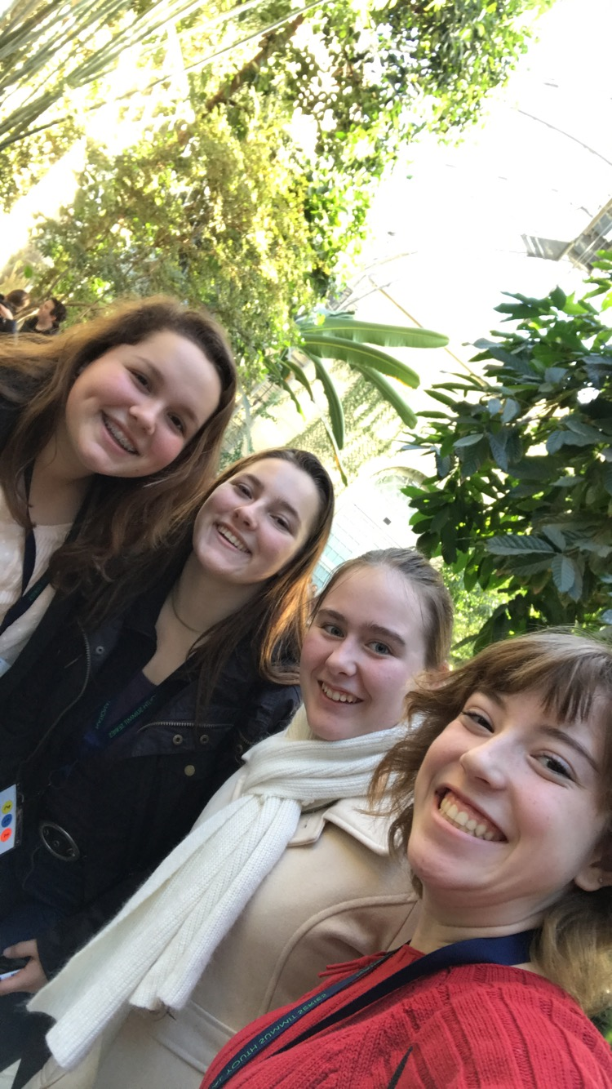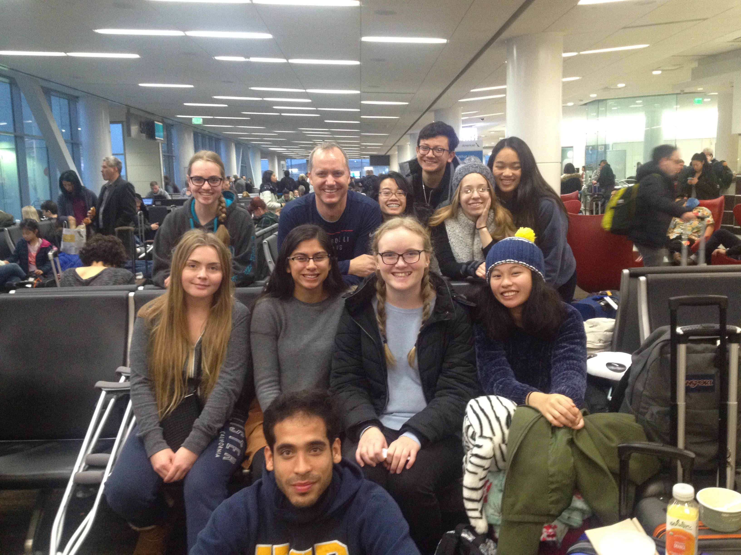

JOANN Fabric and Crafts Partnership with 4-H
- Rewards Card holders get 15% off their total in-store and purchases every day. A minimum of 2.5% of every eligible transaction is donated to National 4-H. Sign up at http://www.joann.com/4-H/ or via App.
- Paper Clover Event February 1-28, 2018; $1 or $4 clovers being sold. $4 clover includes a coupon for $4 off your next purchase. Help spread the word! Post on social media using #JOANNhearts4H and tag us at @California4H.
- JOANN and 4-H are sponsoring a 4-H Online Fashion Contest – Submit photos between February 3 to 23 and entrants must be a current 4-H member between the ages of 14-19. See complete rules and submission requirements at https://4-h.org/get-involved/partners/joann-fabric-craft-stores/#!fashion-contest

Tractor Supply Hardware - ???
Job Posting - ???
WRLF - ???

FACILITY USE
Requests are processed Monday & Wednesdays. Questions may be directed to Lisa via email.

ALL events/gatherings/meetings (organized by 4-H youth/adults) are to be logged using the link below.
- http://ucanr.edu/4hlog

FISCAL

The first installment for the State and County fees have been paid. Please submit payment ASAP.

Mid-year peer reviews – As we are half way through the 2017-2018 program year, now is a good time to consider checking in with your club’s finances. The mid-year peer review form 5.3 can be found in the 4-H Treasurer’s Manual. While not required by policy, it is one way to prepare for a successful end of year reporting.

OUTREACH

Record your Outreach activities as they happen at http://ucanr.edu/outreach or complete the Outreach Methods Documentation Form.
- Collect outreach stories, published news articles, photos or anything positive about 4-H youth and/or the 4-H program.

ENROLLMENT
Do not confirm any youth members that have not paid fees or turned in a waiver of fees.

Do not confirm any adults until you have been notified by the county office that they have completed the required process.

2017-2018 Contra Costa County 4-H Fees:
Youth - $75.00 ($46 State, $25 County, $4 Council)
Adult - $16.00 ($16 State, $0 County)

New Member Enrollment Deadline: 4/1/2018
This applies to all NEW 4-H members for the 2017/2018 program year. Must be confirmed by club VEC within 4HOnline by deadline.

ENROLLMENT TO DATE FROM 4HONLINE
Active Adults 214, Active Youth 613
Pending Adults 5, Pending Youth 10
Incomplete Adults 1, Incomplete Youth 0

Pending Enrollment: 15
Adults: Oakley (2), Pleasant Hill (2) and Tassajara (1)
Youth: Brentwood (1), Briones (3), Delta-Diablo (1), Lamorinda (1) and Pleasant Hill (4)

Remember There are online course requirements for all adult volunteers. New Volunteer information is at: http://4hcontracosta.ucanr.edu/Join-4-H/County_Volunteer/

UPCOMING TRAININGS
There is a Beginning 4-H for Volunteers scheduled for Sunday, February 25, 2018. It will be at UCCE Contra Costa in Pleasant Hill. This training will be good for New Camp Program Volunteers, Volunteers to complete current program year and Volunteers that would like to be ready for the 2018/2019 program year.

4-H Branding Toolkit

Find on the CA 4-H Website under “Resources”
http://4h.ucanr.edu/Resources/Branding_Toolkit

