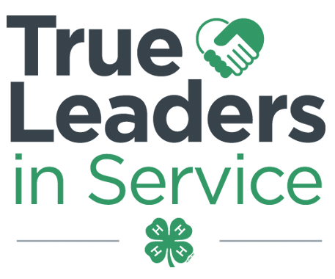**Contra Costa County 4-H Resource Center** [**http://4hcontracosta.ucanr.edu**](http://4hcontracosta.ucanr.edu)

75 Santa Barbara Rd. Floor 2, Pleasant Hill, CA 94523

[Office] 925-646-6543, [Fax] 925-646-6708

Lisa Arbuckle [Email] lafrederickarbuckle@ucdavis.edu

Brenda Vales [Cell] 707-205-6303, [Email] bcvales@ucanr.edu

**March 5, 2018**

**PROGRAM SUPPORT**

**JOANN Fabric and Crafts Partnership with 4-H**

* Rewards Card holders get 15% off their total in-store and purchases every day. A minimum of 2.5% of every eligible transaction is donated to National 4-H. Sign up at <http://www.joann.com/4-H/> or via App.
* Paper Clover Event **Extended to March 31, 2018**; $1 or $4 clovers being sold. $4 clover includes a coupon for $4 off your next purchase. Help spread the word! Post on social media using #JOANNhearts4H and tag us at @California4H.

[**Fundraising Approval Form**](http://4h.ucanr.edu/files/19878.pdf) **8.7 needed for every Fundraiser**  
A fundraising form needs to be completed and sent to the office for approval prior to the event. The form may be found in the CA 4-H Treasurers Manual (pages 49-50). If there is money exchanging hands a form is required. This includes but, is not limited to: Selling food at events, Garage sale/White Elephant Sale, Spaghetti feed, Silent Auction, Photo Booth

**4-H Donation policy reminders  
4-H may not donate Cash/Check to an outside organization**

**~ Can 4-H members fundraise to benefit outside groups or organizations?**

*4-H groups may collect non - cash items (e.g., jackets, toys, food) or cash contributions (cash or checks) that are then used to buy supplies and materials to carry out their service learning activity. They may not donate cash to any group or organization outside of 4-H. All fundraising conducted by a 4-H unit or VMO requires approval of the UCCE county director.*

*When a 4-H group engages in a fundraising activity to benefit another group (e.g., fire victims) or organization (e.g., Red Cross), they must post a sign or otherwise make clear to potential donors that the funds will be used to benefit the other group (e.g., fire victims) or organization (e.g., Red Cross).*

~ **Why can’t 4-H units and VMOs fundraise and donate cash (or checks) to an outside group or organization?**

*4-H is an educational youth development program and as such it is appropriate for 4-H members to conduct fundraising activities in support of outside groups and organizations as part of a service learning activity. These activities are permitted because they provide a high - quality youth development experience as part of the mission and framework of the UC 4-H YDP. Giving cash contributions is a low service activity and as such not aligned with the goals of 4-H.*

*Guidelines -*[*http://4h.ucanr.edu/files/156259.pdf*](http://4h.ucanr.edu/files/156259.pdf)

*FAQ -*[*http://4h.ucanr.edu/files/156260.pdf*](http://4h.ucanr.edu/files/156260.pdf)

**4-H may not receive a donation of $1,000 or more without the County Directors Approval.**Any proposals of significant gifts, (e.g., those in the amount of $1,000 (one thousand dollars and no cents) or greater), that are given with or without restrictions; gifts of real estate; or gifts proposed as endowments must be reviewed and approved prior to acceptance by the county director*, in coordination with the [ANR Development Services Director](http://ucanr.edu/Development_services/).

**FACILITY USE**

Requests are processed Monday & Wednesdays. Questions may be directed to Lisa via email.

ALL events/gatherings/meetings (organized by 4-H youth/adults) are to be logged using the link below.

* <http://ucanr.edu/4hlog>

**FISCAL**

**Mid-year peer reviews** – As we are half way through the 2017-2018 program year, now is a good time to consider checking in with your club’s finances. The mid-year peer review form 5.3 can be found in the 4-H Treasurer’s Manual. While not required by policy, it is one way to prepare for a successful end of year reporting.

**OUTREACH**

Record your Outreach activities as they happen at <http://ucanr.edu/outreach> or complete the Outreach Methods Documentation Form.

* Collect outreach stories, published news articles, photos or anything positive about 4-H youth and/or the 4-H program.

**ENROLLMENT**

**Regarding youth enrolling in 4-H, they may not participate in any 4-H events or activities until they are fully enrolled and Active in 4hOnline.**

**New Member Enrollment Deadline: 4/1/2018**

This applies to all NEW 4-H members for the 2017/2018 program year. Must be confirmed by club VEC within 4HOnline by deadline.

It is the Clubs responsibility to reject the youth and adults that are not participating in the 4-H Club by the enrollment due date April 1, 2018.

**UPCOMING TRAININGS**

No trainings are scheduled at this time.

**4-H Branding Toolkit**

Find on the CA 4-H Website under “Resources”

<http://4h.ucanr.edu/Resources/Branding_Toolkit>