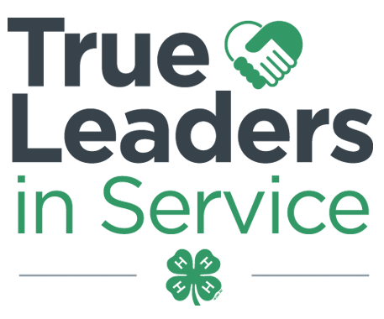
Contra Costa County 4-H Resource Center http://4hcontracosta.ucanr.edu
75 Santa Barbara Rd. Floor 2, Pleasant Hill, CA 94523
[Office] 925-646-6543, [Fax] 925-646-6708
Brenda Vales [Email] bcvales@ucanr.edu

April 2, 2018

PROGRAM SUPPORT
Open Program Representative Position
The Alameda and Contra Costa 4-H Program is seeking to refill a part-time 10 hours/week (.25 FTE) 4-H CES 2 position. The current focus of work assigned to this position is to support the Alameda and Contra Costa 4-H Programs on the facility use education, documentation, MOU /Insurance/Agreement processing for 4-H program use and to help expand the 4-H programs.
Anyone, over 18, who is interested should send their letter of interest and resume to Charles Go at cggo@ucanr.edu.

Science Matters at the Fair
The Science Matters Project will be participating in the School Tours event during the Contra Costa County Fair on Friday, May 18 from 9AM-12PM. We are looking for volunteers to help us set-up, running booths and clean-up. Please contact Brenda for more details.

Raise Your Hand from April 1 to May 15
This year’s Raise Your Hand campaign is counting each hand raised as a vote for your state! You will have the choice to choose which state to raise your hand for.

The states with the most hands raised will win $20,000, $10,000 or $5,000

Mark your calendars on April 1st to start sharing the link to 4-h.org/RaiseYour Hand!

Apply to be on a 4-H Advisory Committee
http://4h.ucanr.edu/Get_Involved/Advisory_Committees/ - Applications due May 31, 2018

Out of Office
April 9 – 12 ANR Statewide conference

FACILITY USE
Please direct questions to Brenda until further notice.

ALL events/gatherings/meetings (organized by 4-H youth/adults) are to be logged using the link below.
- http://ucanr.edu/4hlog

FISCAL
Please plan ahead for year-end report completion.
It is a good idea to start asking for Peer Review volunteers now.

Due to the County 4-H Office by June 30, 2018:
2018/2019 Request to assess a 4-H Club fee

Due to the County 4-H Office by September 15, 2018
2017/2018 6.2 Annual Inventory Report
2017/2018 6.3 Annual Financial Report
2017/2018 8.5 Year-End Club Peer Review
2017/2018 8.6 Year-End Club Peer Review Checklist
2017/2018 Club Program Planning Guide
2017/2018 Outreach Methods Documentation Report
2018/2019 Proposed Club Program Planning Guide
2018/2019 proposed Club Budget
2017/2018 Treasurer Book and Secretary Book

OUTREACH

Record your Outreach activities as they happen at http://ucanr.edu/outreach or complete the Outreach Methods Documentation Form.
- Collect outreach stories, published news articles, photos or anything positive about 4-H youth and/or the 4-H program.

ENROLLMENT
Club Statements have been emailed and are in your club folder.

Reminder – youth and adults enrolling in 4-H may not participate in any 4-H events or activities until they are fully enrolled and Active in 4hOnline.

Projected 2018-2019 Contra Costa County 4-H Fees:
Youth - $80.00 ($50 State, $30 County, $TBD Council)
Adult - $18.00 ($18 State, $0 County)
Note: For youth, State fees increased $4, County fees increased $5, Council fee TBD. For adults, State fees increased $2, County fees remained the same.

UPCOMING TRAININGS
Beginning 4-H for Volunteers – May 5, 2018 – 10AM-2PM – UCCE Contra Costa
Must have a minimum of 10 registered to host training.

4-H Branding Toolkit

Find on the CA 4-H Website under “Resources”
http://4h.ucanr.edu/Resources/Branding_Toolkit

